**COMSATS University Islamabad, Lahore Campus**

3/19/2023

**Hand Slide**

(Digital Image Processing)

**Member 1:** *Hassan Abdullah*

**Reg No.:** *FA20-BCS-012 B*

**Member 2:** *Mahed Shahzad*

**Reg No:** *FA20-BCS-032 B*

**Member 3:** *Hamid Masood*

**Reg No:** *FA20-BCS-039 B*

**About Hand Slide**

Hand Slider is Hand Gesture Controlled Virtual Assistant to present without any need help of an individual or any hardware device to control the flow of presentation. We will be creating a Software Based assistance by which a presentation will be controlled by presenter directly by hand gestures, including switching from slide to slide, marker and undoing marks with hands only. We will use Computer Vision and DIP in Python to make this work.

**Motivation**

A Presenter while presenting has to ask someone to switch from slide to slide, or has to do it by him/her self. Also for pointing on slide or to mark something, he or she has to use a laser pointer or hand to mark something while presenting.

Technology has evolved so much in last few years, so why not we build a easy to use Computer Vision Application that make the Presenter Independent of each of these restrictions.

**Similar Projects / Work**

A lot of work has been done on hand gesture control and gesture recognition. But we don’t find any specific easy to use Application for Presentation control using hand gestures.

* Application where we can control our mouse cursor with hand gestures, but it’s not much accurate.
* We have seen a lot of work done on Hand gestures in Sign Language for Deaf People.
* Hand Gestures to Play and Pause Media Player.
* Using Hand Gesture to control Drone.
* Lamp light Control using hand gesture and so on.

There is a lot of work can be done using Hand Gestures and can solve basic to advance problems, So we trying to do the same by solving a specific daily problem that one may face while presenting.

**Implementation**

Technologies:

* Python
* OpenCV
* Digital Image Processing

***First Step***

Our first Step will be to detect a person’s hand who is going to present. Then for further computation the predefined gestures with useful commands will be detected and According to that change will be done.

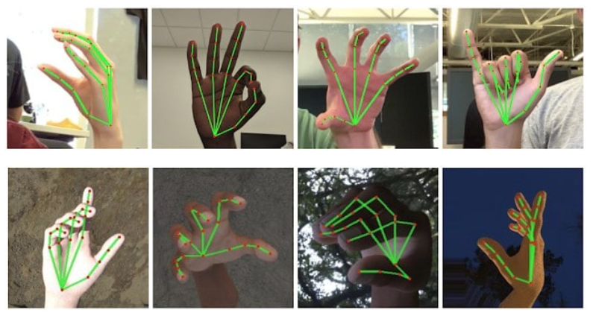

***What and when to do***

* **Gesture (1) to move to next Slide:**

We will use a hand Gesture by which the user will be able to switch to next slide.

* **Gesture (2) to move back to previous Slide:**

A Hand Gesture by which we will enable user to switch back to previous slide.

* **Gesture (3) to enable a Pointer and Move around:**

We will use Single or Double Finger to enable a pointer which will be handled by the user’s hand gesture.

* **Gesture (4) to draw with Pointer:**

After Enabling Pointer User will be able to draw using it with a Specific Hand Gesture.

* **Gesture (5) to undo last draw:**

User will be able to undo what he or she has drawn previously by using a specific gesture.

All the Hand Gesture are TBD.

**Distance from camera:** A person should be in front of camera, far enough to be detected in camera and his or her hand gesture should be detected easily.

Gestures other than the predefined ones will not help. User must use the specific gesture for specific task.

(Any Kind of Recommendations and Feedback is Accepted. We will provide detailed explanation soon once we start proper work on this Project.)